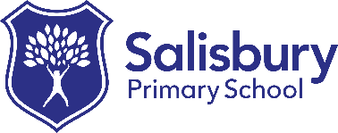**Salisbury Primary School**

**Music Curriculum Overview 2022-2023**

Pupils in KS1 and KS2 are provided with all year round opportunities to experience and learn Music through an external provider. The approach is whole class delivery but pupils are taught to play a musical instrument with good technique appropriate to that chosen instrument. Instruments include keyboards, drum kit, steel drum, glockenspiel and melodica.

The repertoire taught includes pop and rock music, film themes and instrumental pieces. The history of music is also discussed, along with social structures that may have given rise to a particular genre, for example; Brit Pop.

During the course of the school year, pupils engage in a range of music projects and concerts. This provision helps to encourage our pupils to pursue their individual interests in learning to play their chosen instrument.

|  |  |  |  |  |  |  |
| --- | --- | --- | --- | --- | --- | --- |
|  | **AUTUMN 1** | **AUTUMN 2** | **SPRING 1** | **SPRING 2** | **SUMMER 1** | **SUMMER 2** |
| **Year 1** | Singing | Singing | Singing  History of music | Singing  History of music | Ensemble | Ensemble  Musical Notation |
| **Year 2** | Singing | Singing | Ensemble | Ensemble  Musical Notation | Singing | Singing |
| **Year 3** | Ensemble | Ensemble  Musical Notation | Singing  History of music | Singing  History of music | Singing | Singing |
| **Year 4** | Ensemble  Musical Notation | Ensemble  Musical Notation | Singing | Singing | Singing  History of music | Singing  History of music |
| **Year 5** | Singing | Singing | Ensemble  Musical Notation | Ensemble  Musical Notation | Singing  History of music | Singing  History of music |
| **Year 6** | Ensemble  History of music | Ensemble  Musical Notation | Ensemble  History of music | Ensemble  Musical Notation | Ensemble  Musical Notation | Graded music exams |